**Year 8 Earth and Space Sciences 2022**

**Mid Unit Test**

**Section 1: Multiple Choice Answers 1 mark each**

*Read all answers and choose the* ***BEST*** *one.*

1. **Rocks are made of:**
2. Marble, quartz, coal and many more.
3. lava.
4. only one mineral.
5. a mixture of minerals.
6. **Molten rock beneath the earth’s surface is:**
   1. Lava
   2. Magma
   3. Crust
   4. Sandstone
7. **The three main rock types are:**
   1. Igneous, basalt and metamorphic
   2. Granite, pumice and marble
   3. Magma, sedimentary and metamorphic
   4. Igneous, sedimentary and metamorphic
8. **What are the four main layers of the earth?**
9. Inner core, Outer Core, Mantle, Crust
10. Inner core, Outer Core, Mantle, Magma
11. Magma, Lava, Outer Core, Inner Core
12. Volcanoes, Earthquakes, Plate Tectonics, Crust
13. **Igneous rocks are:**
14. Made of rounded grains cemented together.
15. Left behind when a solution evaporates.
16. Formed from eroded sediment.
17. Made of interlocking crystals.
18. **The two types of Igneous rocks are:**
19. Intrinsic and Extrusive
20. Intricate and Extrusive
21. Intrusive and Extrusive
22. Instigate and Extrusive
23. **A metamorphic rock is formed by the:**
24. Slow cooling of molten magma to form large crystals.
25. Deposition and cementing of eroded particles.
26. Rapid cooling of molten magma to form crystals.
27. Effects of great heat and pressure on rock.
28. **The two most common processes that change piles of sediment into a sedimentary rock are:**
29. Deposition and sedimentation.
30. Weathering and erosion.
31. Compaction and cementation.
32. Cooling and crystallization.
33. **The Rock Cycle is best described as:**
34. A process by which metamorphic rocks change colour and size.
35. The changes in Igneous, metamorphic and Sedimentary rocks.
36. The changes in Igneous and Sedimentary rocks.
37. The changes in igneous and Metamorphic Rocks.
38. **Coal is a sedimentary rock that forms when:**
39. Plants fall into lava and become burned to a black charcoal.
40. Bacteria in soil partially decompose and leave behind a black residue.
41. Tiny ancient single celled organisms became buried under soil that turned into rock.
42. Plants and animals are buried and compressed between rock layers.
43. **If you were told that a rock you were studying was a sedimentary rock, you could be reasonably sure that it had formed when:**
    1. Another type of rock was changed by high temperatures and extreme pressures
    2. Molten lava had cooled and became solid
    3. Molten magma had cooled and solidified
    4. Materials that had settled in water were compressed and cemented together
44. **The diagram to the right shows a geological cross-section of a region.**

**Which one of the following is the youngest rock in the region?**

* 1. Basalt.
  2. Granite.
  3. Mudstone.
  4. Sandstone**.**

1. **Sedimentary rocks are classified into which 3 groups:**
   1. Physical, chemical and biological(organic)
   2. Clastic, biological (organic) and chemical
   3. Organic, inorganic and chemical
   4. Clastic, biological(organic) and mineral
2. **A clastic sedimentary rock is:**
   1. A rock formed from weathered rock fragments
   2. Transformed through heat and pressure
   3. A rock formed from organic material
   4. A rock formed from molten rock
3. **Metamorphic rocks with mineral crystals arranged in parallel layers, or bands, are:**
   1. clastic
   2. extrusive
   3. intrusive
   4. Foliated
4. **The presence of holes in pumice is due to:**
   1. Magma cooling quickly
   2. Heat and pressure
   3. Weathering and erosion
   4. Trapped gases as the rock cools
5. **Rocks can change by many different processes through the rock cycle. All of the following processes change rocks on Earth’s surface except:**
6. Weathering
7. Melting
8. Deposition
9. Compaction
10. **During which process does layer upon layer of sediment build up, exerting pressure on the layers below?**
    1. Deposition
    2. Compaction
    3. Erosion
    4. Weathering
11. Marika and Michael are going to build their first home out of local rocks. They visit some quarries looking for hard, weather-resistant rock for the walls of their house, some rock that will make nice flat roof tiles, a hard-wearing attractive rock for the benchtops in the kitchen, and a soft, pale rock with an even colour and fine texture for an indoor statue that Michael wants to carve in his spare time.   
    **To do all of these jobs, which of the following is the best choice of rocks?**
12. Slate, basalt, marble, conglomerate
13. Granite, sandstone, coal, basalt
14. Conglomerate, mudstone, shale, marble
15. Basalt, slate, granite, marble.
16. **Marble is a metamorphic rock that forms from a_________ parent:**
    1. Granite
    2. Limestone
    3. Sandstone
    4. Shale

**- End of Multiple Choice -**

**Please move on to the Short Answer Section.**

|  |  |
| --- | --- |
| Mount Lawley Senior High School - Wikipedia | **Mount Lawley Senior High School** |
| **Year 8 2022 – Earth and Space Science – Mid Unit Test: Rock Cycle** |
| Name: ___________________________________________________________  Class: _____________________________ Date:_____________________ |

***Section A: Multiple Choice – Please SHADE he best suited answer* 20 marks**

1. A B C D
2. A B C D
3. A B C D
4. A B C D
5. A B C D
6. A B C D
7. A B C D
8. A B C D
9. A B C D
10. A B C D
11. A B C D
12. A B C D
13. A B C D
14. A B C D
15. A B C D
16. A B C D
17. A B C D
18. A B C D

**Multiple Choice: _________ /20**

**Short Answer: ________ / 20**

**Practical: ________ / 10**

**TOTAL: ________ / 50**

1. A B C D
2. A B C D

**Section 2: Short Answer 20 marks**

**Question 1.** Look at the diagrams below and answer the following questions.

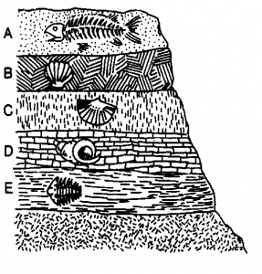The diagram below shows a section from a cliff. The cliff is made of sedimentary rock. Various fossils are shown in the different layers. A fossil is a preserved trace of a dead organism trapped in rock a long, long time ago.

1. Which layer (A, B, C, D or E) contains

E

the oldest fossil? ___________________ (1 mark)

(b) Explain your answer in relation to how sedimentary rocks are formed. (2 marks)

Being a sedimentary rock, the layers below must be older than the ones above, because deposition occurs downwards.

Award the mark if it is clear that the student understands that the **lowest layer must be formed first.** (1 mark)

**Erosion moved new sediment** on top (1 mark) OR

Layers and **explaining the processes of deposition and compaction** (1 mark)

Don’t award the mark if they say “because layer E is at the bottom” as this doesn’t confirm that they understand that.

_______________________________________________________________________________________  
_______________________________________________________________________________________  
_______________________________________________________________________________________  
_______________________________________________________________________________________

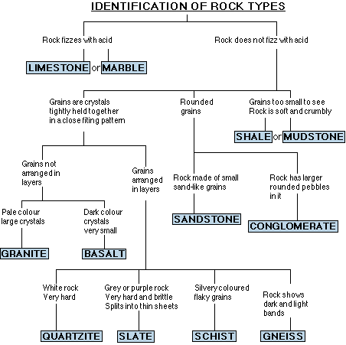**Question 2.** Examine the key to identifying rock types shown below and use the information in it to help you answer the questions below.

1. i. What test would you carry out, in order to tell if a particular rock was LIMESTONE or SANDSTONE? (1 mark)

___________________________________________________________________________  
___________________________________________________________________________

Mix the stone with some acid and see if there is a fizz

ii. What result/reaction would tell you that it was actually SANDSTONE? (1 mark)

If there was no fizz/bubble

___________________________________________________________________________  
___________________________________________________________________________

(b) What is the main difference between GNEISS and GRANITE? (1 mark)

Granite has grains not arranged in layers, while Gneiss has grains arranged in layers

Gneiss has bands/layers

___________________________________________________________________________  
 ___________________________________________________________________________

(c) Give one feature that you would expect to see in both GNEISS and GRANITE. (1 mark)

Grains have crystals tightly held together in a close-fitting pattern

Does not fizz with acid

___________________________________________________________________________  
 ___________________________________________________________________________

**Question 3.** The questions in this section are designed so that you may have to figure out the answer.

The minerals in rocks found near the top of a mountain can eventually become part of the sand at the bottom of a river.

1. Describe three ways in which the boulders at the top of a mountain might be broken to become smaller pebbles as time passes. (3 marks)

**½ a mark for the factor and ½ for the effect the factor has on the rock x3**

* + 1. Wind may wear them down (sand blasting)
    2. Gravity may cause them to tumble and break up
    3. Ice may cause them to crack
    4. Plant roots/acid may split them open
    5. Temperature changes may cause cracks or crumbling
    6. Rain may wash/dissolve minerals them away or break while tumbling in river.

_______________________________________________________________________________________  
_______________________________________________________________________________________  
_______________________________________________________________________________________  
_______________________________________________________________________________________  
_______________________________________________________________________________________  
_______________________________________________________________________________________

1. At the bottom of the river, you might notice that there are fewer big pebbles towards the end of the river than there were at the beginning of the river. Explain this observation. (2 mark)

Larger pebbles are likely to be heavier (1 mark) and therefore more difficult for the flowing river to carry Smaller pebbles are lighter (1 mark) and therefore get carried further (1 mark)

OR

The river moves slower at its end (1 mark) so only the lighter particles can still be carried and/or as rocks travel in the river they break becoming smaller. (1 mark)

Or Weathering over time to smaller pebbles that could me moved downstream

_______________________________________________________________________________________  
_______________________________________________________________________________________  
_______________________________________________________________________________________  
_______________________________________________________________________________________  
_______________________________________________________________________________________

**Question 4. Match** the words to the correct definition, by writing the number in the box. (3 marks)

2

3

1

|  |
| --- |
|  |
|  |
|  |

A. Weathering 1. Settling down of weathered rock

B. Erosion 2. Breakdown of rocks

C. Deposition 3. Movement of weathered rock

**Question 5. Fill in** the boxes to complete the Rock Cycle? (5 marks)

½ mark for each word:

Heat ( ½ ) and Pressure ( ½ )

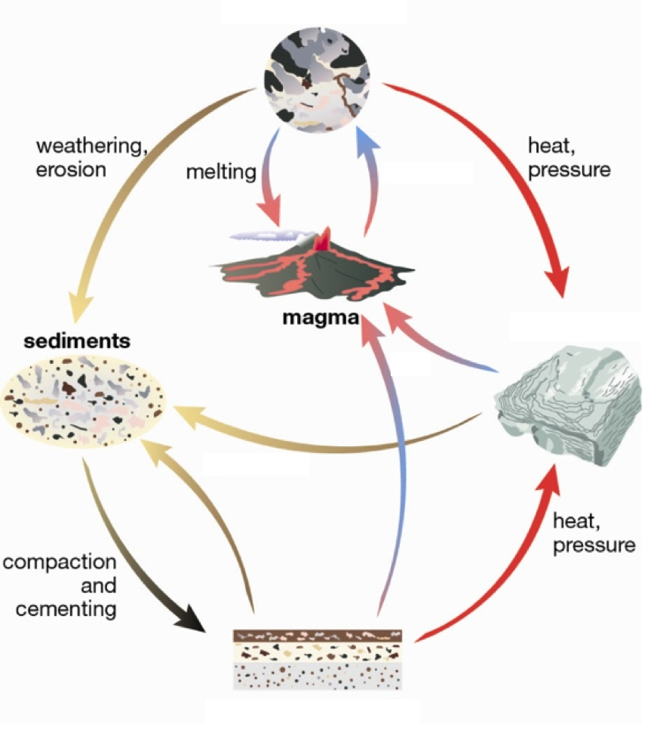

Heat and Pressure

Weathering and Erosion

Compaction and Cementation

Melting

Cooling

**Section 3: Practical activity 10 marks**

1. a) **Circle** what type of rock **# A** is: Igneous / Sedimentary / Metamorphic (1 mark)

b) **Explain** your choice for rock **#A based on observed features** (2 mark)

Air bubbles from trapped gas (1 mark) indicating rapid cooling in ash cloud (1 Mark)

|  |
| --- |
|  |

c) **Name** and **classify** rock **#A** using your observations of the rock. (2 marks)

Pumice Extrusive

Name: _____________________ Classification: ____________________

1. a) **Circle** what type of rock **#B** is: Igneous / Sedimentary / Metamorphic (1 mark)

b) **Explain** your choice for rock **#B based on observed features** (2 marks)

|  |
| --- |
| Can visually observe that the rock is made up of sediments/pebbles (1 mark) that have been compacted and cemented together (1 marks) |

c) **Name** and **classify** rock **#B** using your observations of the rock. (2 marks)

Conglomerate Clastic

Name: _____________________ Classification: ____________________

**- *END OF TEST –***